PWM AND DRIVER INTEGRATION

# THE PROJECT GALLERY:

# THE SOLDERED CIRCUIT

# 

**THE PULSE WIDTH MODULATOR**

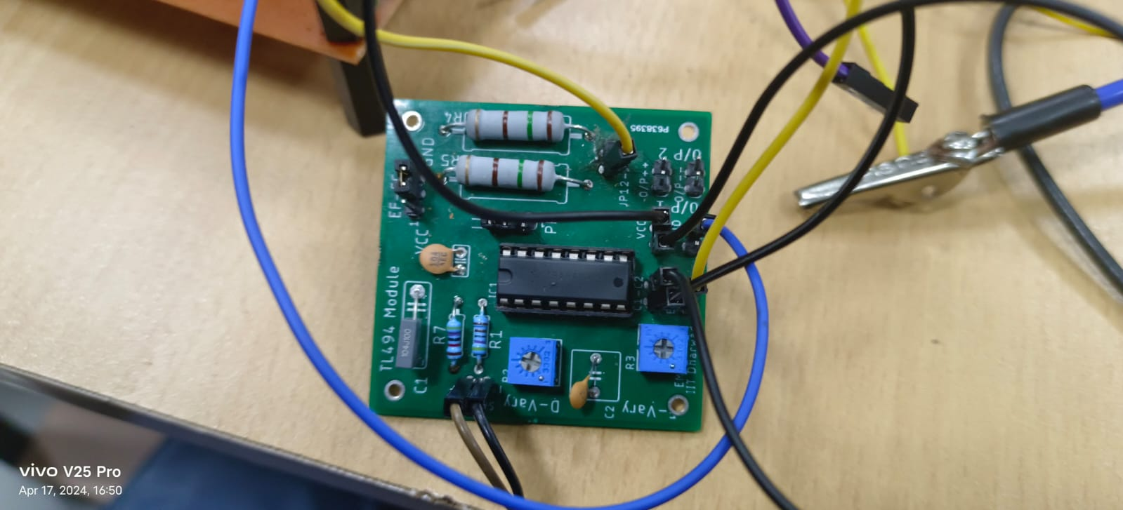

**DIODE CURRENT WAVEFORM**

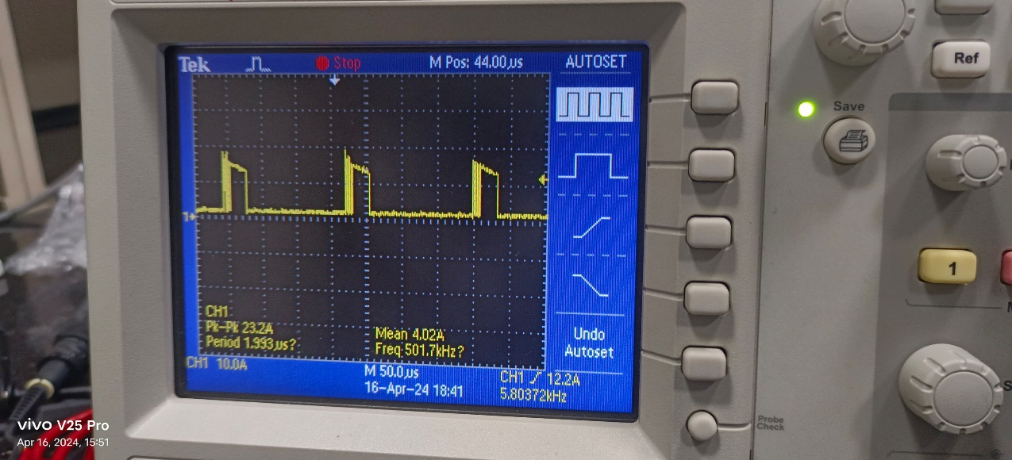

**PWM OUTPUT**

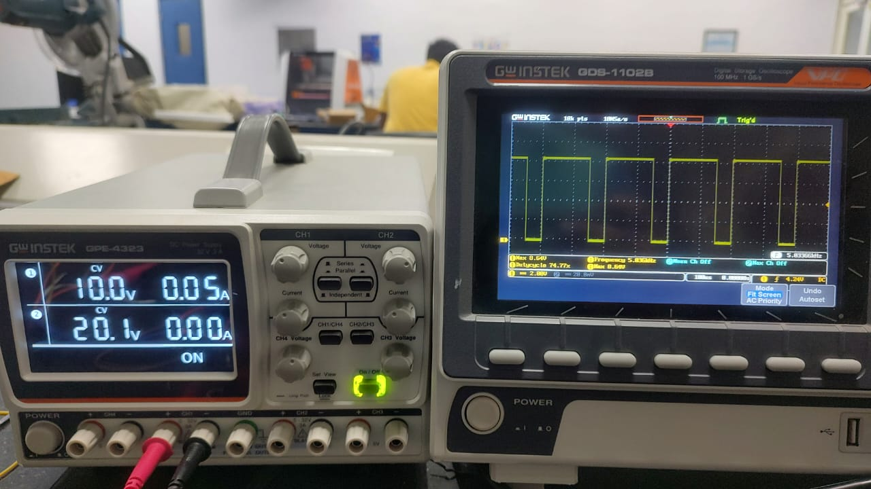

**BY MATLAB SIMULATION WITH DRIVER OUTPUT WITH 75 % DUTY CYCLE AND DRIVER OUTPUT WITH FREQUENCY 5KHz**

INPUT PULSES

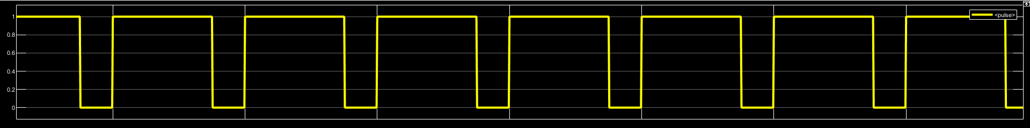

OUTPUT VOLTAGE

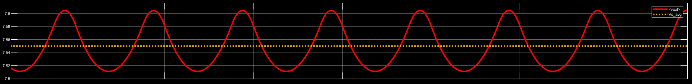

OUTPUT CURRENT

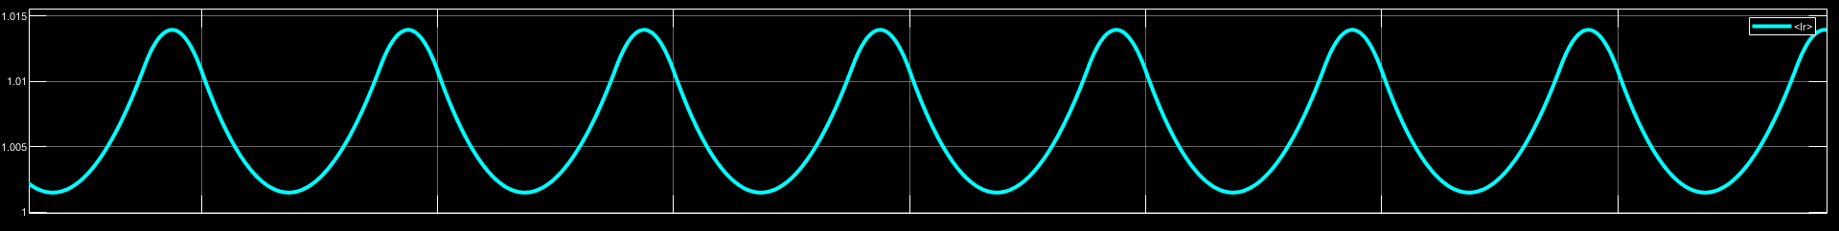

DIODE CURRENT

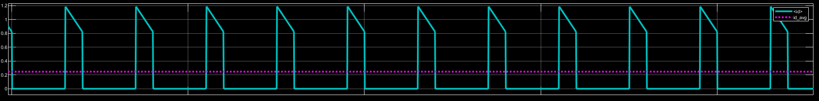

INDUCTOR VOLTAGE

